Java Server Pages (JSP)
Table of Contents
What is JSP? 2
Difference between JSP and HTML 2
Advantages of JSP over Servlets 2
1. Extension to Servlet 2
2. Giving flexibility to Designing 3
3. Easy to maintain 3
4. Fast Development 3
5. Less code than Servlet 3
Lifecycle of JSP Page 3
Translation 4
Compilation 4
Class Loading 4
Instantiation 4
Initialization 4
Thread Creation & Request Processing 5
Destroy is called 5
Important Points 5
JSP Architecture 5
JSP Architecture Flow 6
First JSP program in Eclipse 6
Directory structure of JSP 7
The JSP API 7
Package javax.servlet.jsp 7
Interfaces 7
Classes 7
JSP Page (I) 8
Methods of JspPage interface 8
HttpJspPage (I) 8
Method of HttpJspPage interface 8
Interview Questions 9
Q1. What is the task of JSP Engine? 9

What is JSP?
- JSP stands for Java Server Pages
- JSP is a java technology (just like Servlets) used to create web applications.
- JSP is developed to solve some limitations and problems of Servlets
- JSP can be said as an extension to Servlet
- It means -
  - Whatever we could do in Servlets we can also do in JSP with more ease.
  - JSP provides additional functionalities of its own
- A JSP page consists of HTML tags and JSP tags.
- JSP pages are easier to maintain than Servlet
- Using JSP we can separate designing and development.

Difference between JSP and HTML
The differences between JSP and HTML are given below:
S. No. | HTML | JSP
1. | HTML is a Client side technology | JSP is a Server side technology.
2. | HTML generates static web pages. | JSP generates dynamic web pages.
3. | HTML is given by W3C (World Wide Web Consortium). | JSP is given by Sun Micro System.
4. | An HTML page can have only HTML tags and content | A JSP page can have both - HTML as well as java code.
5. | Need HTML Interpreter to execute this code. | Need JSP container to execute JSP code.
6. | It does not allow us to place custom tag or third party tag. | It allows us to place custom tag or third party tag.
7. | The file with all HTML content has .HTML or .htm extension | The file with even 1 JSP statement must have .jsp extension

Advantages of JSP over Servlets
“Servlet is HTML inside Java”, while “JSP is Java inside HTML”.

There are many advantages of JSP over the Servlet. They are as follows:

Extension to Servlet
- JSP technology is the extension to Servlet technology.
- We can use all the features of the Servlet in JSP, plus
- JSP provides additional functionalities (such as implicit objects, directives, third party tag libraries, expression language) of its own that makes development faster and easier

Giving flexibility to Designing
- Both JSP and Servlet can be used to design a web page
- Servlet used out.println() to generate static web content at runtime.
- Designing a web page with “out.println()” is exponentially cumbersome
- JSP eases designing by embedding dynamic java code inside static HTML code

Easy to maintain
- JSP can be easily managed because we can easily separate our business logic with view logic.
- In Servlet technology, we mix our business logic with the view logic.

Fast Development
- If a Servlet is modified, code will be recompiled & redeployed for the changes to take place
- If JSP page is modified, code will be recompiled but will not redeploy for changes to take place

Less code than Servlet
In JSP, we can use predefined and pre-initialized tags such as action tags, JSTL, custom tags, and EL, implicit objects, etc. that helps reduce the code. These features are not available in Servlets.

Lifecycle of JSP Page
The JSP pages follow these phases:
- Translation of JSP Page
- Compilation of JSP Page
- Class loading (the class-loader loads class file)
- Instantiation
- Initialization
- Request processing
- Response Generation
- Destroy
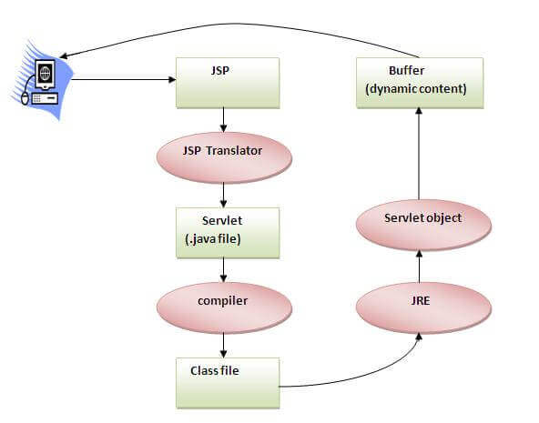

Translation
- JSP page is translated into Servlet by the help of JSP engine, i.e. (XXX.jsp to XXX.java)
- The JSP engine is a part of the web server
From here Servlet Life Cycle begins as discussed earlier in Servlet Life Cycle. Here they are for your quick revision:

Compilation
The translated Servlet page is then compiled by the JSP Engine into class file. (XXX.java to XXX.class)
You can find the .class files of .jsp’s at the path:
[<eclipse-workspace> \ .metadata \ .plugins \ org.eclipse.wst.server.core \ tmp0 \ work \ Catalina \ localhost \ <project-context> \ org \ apache \ jsp]

Class Loading
The Servlet class is than loaded into the memory

Instantiation
Object of the Generated Servlet is instantiated

Initialization
The container invokes _jspInit() method

Thread Creation & Request Processing
The container invokes _jspService() method, we get request and response objects to get data and output the response

Destroy is called
The container invokes _jspDestroy() method

Important Points
- The methods _jspInit(), _jspDestroy() and _jspService() of the translated Servlet corresponds to init(), destroy() and service() (doGet(), doPost()) of a regular servlet.
- Similar to servlet's service(), _jspService() takes two parameters, request and response, encapsulating the HTTP request and response messages.
- Similar to PrintWriter object, a JSP translated Servlet provides JspWriter object to write the response message over the network to the client.
- The HTML statements in the JSP script are written out as part of the response via out.write(...), as it-is without modification.
- The Java code in the JSP scripts are translated according to their type of tag used:
  - The code written inside JSP Declaration tag is placed in translated Servlet class as it data members and member methods
  - The code written inside JSP Scriptlet is placed inside the _jspService() method of the translated servlet as "it is". Scriptlets form the program logic.
  - The code written inside JSP Expression is placed inside an “out.print (...)” inside _jspService()

JSP Architecture
Java Server Pages are part of a 3-tier architecture. A server (generally referred to as application or web server) hosts and supports the Java Server Pages. This server will act as a mediator between the client browser and a database. The following diagram shows the JSP architecture.
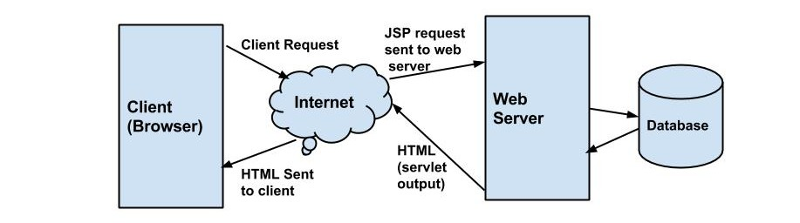

JSP Architecture Flow
- The user requests a JSP page from the client browser
- The browser sends an HTTP request to the web server.
- The web server recognizes that the HTTP request is for a JSP page and forwards it to a JSP engine.
- The JSP engine loads the JSP page from disk and translates it into an equivalent Servlet source code.
- The JSP engine compiles the servlet into an executable class and forwards the original request to a servlet engine.
- A part of the web server called the servlet engine loads the Servlet class and executes it.
- During execution, the servlet produces an output in HTML format.
- The output is further passed on to the web server by the servlet engine inside an HTTP response.
- The web server forwards the HTTP response to the user’s browser in terms of static HTML content.
- Finally, the web browser handles the dynamically-generated HTML page inside the HTTP response exactly as if it were a static page.

First JSP program in Eclipse
Step 1. Start Eclipse
Step 2. Create a new “Dynamic Web Project”
Step 3. Create a JSP page inside the Web Content folder in the new project.
Step 4. Write some JSP code in the <body></body> tag.
Step 5. Run the file on server.
Step 6. See the output on the browser.
Step 7. Locate the translated servlet and class files at below path:
[<workspace-path>\.metadata\.plugins\org.eclipse.wst.server.core\tmp0\work\Catalina\localhost\<project-name>\org\apache\jsp]

Directory structure of JSP
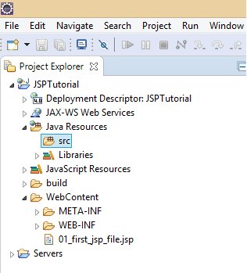

The JSP API
The JSP API consists of two packages:
- javax.servlet.jsp
- javax.servlet.jsp.tagext

Package javax.servlet.jsp

Interfaces
- JspPage
- HttpJspPage

Classes
- JspWriter
- PageContext
- JspFactory
- JspEngineInfo
- JspException
- JspError
- HttpJspBase

JSP Page (I)
According to the JSP specification, all the generated servlet classes must implement the JspPage interface. It extends the Servlet interface. It provides two life cycle methods.
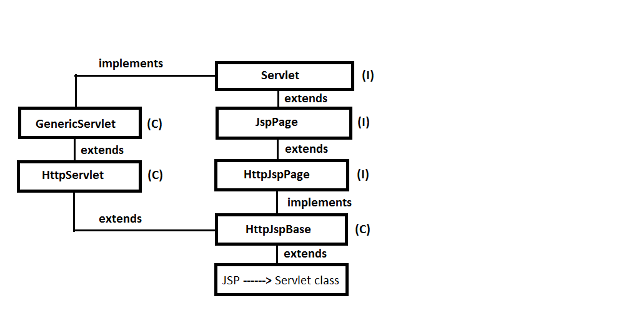

Methods of JspPage interface
- public void jspInit(): It is invoked only once during the life cycle of the JSP when JSP page is requested for the first time. It is used to perform initialization. It is same as the init() method of Servlet interface.
- public void jspDestroy(): It is invoked only once during the life cycle of the JSP before the JSP page is destroyed. It can be used to perform some cleanup operations.

HttpJspPage (I)
The HttpJspPage interface provides one life cycle method of JSP. It extends the JspPage interface.

Method of HttpJspPage interface
- public void _jspService(): It is invoked each time when request for the JSP page comes to the container. It is used to process the request. The underscore _ signifies that you cannot override this method.

Interview Questions

Q1. What is the task of JSP Engine?
Answer: The JSP engine
- Validates JSP source, both classic and XML styles
- Translates JSP source to Java classes
- Compiles Java classes, reporting any errors
- Generates Java classes for any tag files that are used by the JSP
- Interfaces with the web container to load JSP class files
- Supports JSP batch compilation, JSP compilation during application installation
- Loads class files, and manage lifecycle (reloading, unloading as necessary)
- Supports debugging of JavaServer Pages files

